  DTID FY27 Channel Alignment  3.0 | High Level summary  Align DTID with FY27 Channel reporting for Attribution models and Adobe data capture  Amanda Pattenden  Digital Marketing Manager

Revision History
Date | Version | Description | Author
19/05/2026 | 1.0 | Draft Document | Amanda Pattenden
19/05/2026 | 2.0 | Review with Stephanie | Amanda Pattenden
26/05/2026 | 3.0 | Request to use full name for Reporting Channel | Amanda Pattenden

Table of Contents

1. Introduction 3
Executive Summary 3
Problem Statement – Why? 3
Vision – What? 3
Business Impact 3
2. Scope and Limitations 4
In-Scope 4
Out of Scope 4
3. Functional Requirements 4
Process Overview 4
New DTID Creation 5
Existing DTID Edits 5
Search Interface 5
Data Bulk Update 5
4. Appendix 6
Appendix A 6
Appendix B 6
Appendix C 7

- Introduction

Executive Summary
As we prepare for the transition to FY27 attribution modelling, our reporting and analytics teams require a mechanism to track performance against a streamlined set of channel definitions. Concurrently, leadership dashboards must remain completely undisrupted, requiring our existing Digital Tracking ID (DTID) structures to remain live in Salesforce (SFDC) for the time being.

To bridge this "hybrid world," this project introduces a system-calculated field called Reporting Channel into the DTID management tool. This field will automatically map legacy and net-new transactional channels to future-state reporting structures based on a standardized backend mapping matrix.

Problem Statement – Why?
Our current state requires marketing operations to select from a broad, historically accumulated list of Channels. Moving into FY27, we need to enforce cleaner data constraints for new marketing activities without breaking or losing the historical context of existing IDs.

- The Constraint: We cannot change the channel architecture inside SFDC yet.
- The Goal: Automate the mapping process at the point of DTID creation/modification so that the data team can ingest a clean, pre-mapped data stream to build and audit the new models.

Vision – What?
This document outlines a requirement to modify the Campaign Tagging & Tracking (CTT) tool to support the data capture of reporting channels alongside vehicles aligned to Drive To IDs (DTID)

As part of our transition to updated FY27 Attribution Models and streamlined Channel reporting, we must bridge the gap between our current operational state and future-state reporting structures.

Legacy tracking identifiers must remain active in Salesforce (SFDC) during this transitional phase, this project introduces a new, dedicated "Reporting Channel" field to the CTT interface as part of the Drive To ID Creation.

This enables parallel reporting capability: maintaining current executive-level leadership reporting "as is" while simultaneously empowering data and reporting teams to build, audit, and validate the new attribution models.

Business Impact
Without a mechanism to map data to both frameworks simultaneously, we face a critical bottleneck:

- Reporting Delays: The analytics team cannot prepare or test the FY27 models.
- Reporting Interruption: Attempting to shift definitions prematurely would break current operational leadership reporting.
- Data Disconnect: Net-new digital marketing activities would lack the necessary metadata to be captured in the upcoming models.

- Scope and Limitations

In-Scope
- Database Schema Update: Add a new string field REPORTING_CHANNEL to the MKW_OMS_IDS data table.
- UI Controls: Modify the DTID Creation Screen and DTID Edit Screen to support conditional dropdown lists and read-only attributes.
- Logic Engine: Implement a backend lookup mechanism where REPORTING_CHANNEL is automatically assigned based on the selected Channel for all new entries
- Search Infrastructure: Expose the new field as a view only parameter in the front-end user portal.
- Data Migration: Execute a one-time backend historical data update using a specific, explicit list of existing DTIDs mapped at the individual ID level, rather than a blanket channel lookup

Out of Scope
- Integration APIs (Tray.io): There is no requirement to include or expose this new field in the Tray.io transaction log API or middleware layers at this time.
- SFDC Core Schema Changes: This change is restricted to the tracking ID generation utility and does not require immediate schema mapping changes within Salesforce.

- Functional Requirements
The core of this request relies on split behaviour depending on whether a record is being created or edited.

Process Overview
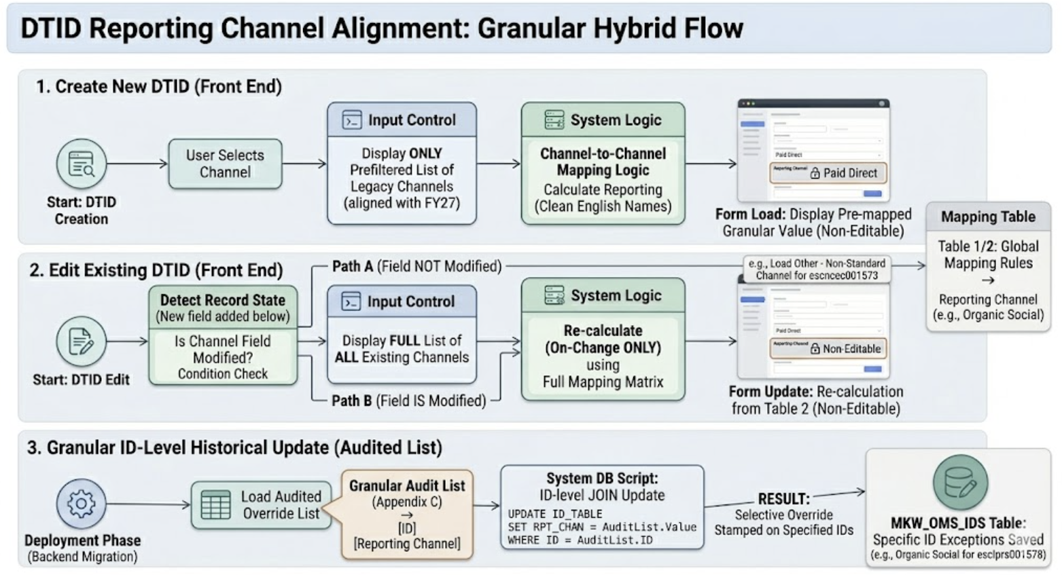

New DTID Creation
- Channel Selection (Input): The UI must restrict the dropdown menu to a predefined subset of existing channels (Table 1 - Create New DTID - LOV). Deprecated or legacy channel values must be hidden from this view to prevent users from selecting them for new campaigns.
- Reporting Channel (Output): This field must be visible on the UI but completely read-only / non-editable by the user.
- Automation Rule: When a user selects a Channel from the dropdown, the UI must dynamically check the Mapping Table (Table 1 - Create New DTID - LOV) and display the corresponding Reporting Channel value on the screen.
- Casing & Hyphenation Rule: All Reporting Channel values must display as full, usable English names (e.g., Organic Social, Paid Direct, Other - Non-Standard Channel). Do not convert these values to lowercase or replace spaces with hyphens.

Existing DTID Edits
- On-Load Preservation Rule: When an existing DTID is opened in Edit Mode, the REPORTING_CHANNEL field must initially display the value currently saved in the database row for that specific ID, regardless of what the standard Channel-to-Reporting-Channel mapping table says. The front-end UI must not execute the automated mapping lookup on initial page load.
- Channel Selection (Input Restriction): When an operator opens an existing record in edit mode, the available channel options must be strictly restricted to the specific list of values defined in (Table 2 - Edit Existing DTID - LOV) Deprecated or inactive codes not explicitly listed in Table 2 must be filtered out and hidden from the drop-down box to prevent invalid retro-mapping.
- Reporting Channel (Output): This field must remain visible and strictly read-only/non-editable.
- On-Change Overide Trigger: The standard mapping lookup engine will only trigger if the user actively interacts with and changes the selected value in the Channel drop-down field. If a new channel from Table 2 is selected, the system must dynamically look up the corresponding value and overwrite the on-screen REPORTING_CHANNEL with the clean English name. (Table 2 - Edit Existing DTID - LOV)
- Save Validation: If a user opens a record like, modifies a completely different field (such as the Description or Sub Vehicle), and clicks "Save" without touching the Channel dropdown, the system must commit the update while leaving the custom REPORTING_CHANNEL value intact.
- Casing & Hyphenation Rule: All Reporting Channel values must display as full, usable English names (e.g., Organic Social, Paid Direct, Other - Non-Standard Channel). Do not convert these values to lowercase or replace spaces with hyphens.

Search Interface
- Add Reporting Channel as a searchable filter field in the DTID search panel.
- Users must be able to search, filter, and export data grids based on these new macro-level reporting categories.

Legacy Codes
- Drop Down exclusions: The front-end UI field constraint for the Edit Screen must explicitly filter out and exclude all legacy codes listed in Table 1 - Create New DTID - LOV . While these historical codes exist in the database and will be updated via the backend migration script, they must be completely hidden from the UI selection box. No user should be able to actively select a Table 3 channel moving forward.

Data Bulk Update
Prior to launching this change to production, the development team must execute a database migration script to populate historical records
The Exception Constraint: The IT team cannot rely on a global channel-to-channel conversion for this migration. Due to historical nuances, data alignment must be processed via a granular audit list (Full Audit of DTIDs as of 09/06/2026) mapped directly by individual ID string
Behavioural Example:
- ID esclprs001578 must explicitly be stamped as Organic Social.
- ID escncec001573 must explicitly be stamped as Other - Non-Standard Channel.
Amanda to amend to show only show new alignment and only the one option – do some examples
- Appendix

Appendix A

Table 1 - Create New DTID - LOV
CODE | NAME | CATEGORY | REPORTING CHANNEL
pdc | Audio Direct | DRIVETO | Paid Direct
apr | Audio – Programmatic | DRIVETO | Paid Programmatic
cs | Content Syndication | DRIVETO | Content Syndication
ddp | Digital Display - Programmatic | DRIVETO | Paid Programmatic
di | Digital Display – Direct | DRIVETO | Paid Direct
dvp | Digital Video - Programmatic | DRIVETO | Paid Programmatic
vi | Digital Video – Direct | DRIVETO | Paid Direct
dm | Direct Mail | DRIVETO | Direct Mail
em | E-mail | DRIVETO | Email
scl | Organic Social | DRIVETO | Organic Social
se | Paid Search | DRIVETO | Paid Search
pdl | Paid Social | DRIVETO | Paid Social

Appendix B

Table 2 - Edit Existing DTID - LOV
CODE | NAME | CATEGORY | REPORTING CHANNEL
pdc | Audio Direct | DRIVETO | Paid Direct
apr | Audio – Programmatic | DRIVETO | Paid Programmatic
cic | Cisco.com | DRIVETO | Other - Non-Standard Channel
cmm | Communities | DRIVETO | Other - Non-Standard Channel
cs | Content Syndication | DRIVETO | Content Syndication
cad | Customer Advocacy | DRIVETO | Other - Non-Standard Channel
ddp | Digital Display - Programmatic | DRIVETO | Paid Programmatic
di | Digital Display – Direct | DRIVETO | Paid Direct
dvp | Digital Video - Programmatic | DRIVETO | Paid Programmatic
vi | Digital Video – Direct | DRIVETO | Paid Direct
dib | Direct Inbound | DRIVETO | Other - Non-Standard Channel
dm | Direct Mail | DRIVETO | Direct Mail
em | E-mail | DRIVETO | Email
ecl | Events - Cisco Live | DRIVETO | Other - Non-Standard Channel
exo | Events: CXO | DRIVETO | Other - Non-Standard Channel
ivt | Events: Field Events 1st Party | DRIVETO | Other - Non-Standard Channel
epy | Events: Field Events 3rd Party | DRIVETO | Other - Non-Standard Channel
efo | Events: Field Events Other | DRIVETO | Other - Non-Standard Channel
egp | Events: Global 3rd Party | DRIVETO | Other - Non-Standard Channel
scl | Organic Social | DRIVETO | Organic Social
ote | Other | DRIVETO | Other - Non-Standard Channel
tl | Outbound | DRIVETO | Other - Non-Standard Channel
se | Paid Search | DRIVETO | Paid Search
pdl | Paid Social | DRIVETO | Paid Social
wfp | Webinars - First Party | DRIVETO | Other - Non-Standard Channel
wtp | Webinars - Third Party | DRIVETO | Other - Non-Standard Channel
ibp | Inbound Phone | DRIVETO | Other - Non-Standard Channel
ibc | Inbound Chat | DRIVETO | Other - Non-Standard Channel

The following Codes should be mapped in the background but should not be in the drop down list box for selection in Edit mode:
Table 3 - Not in Selection - but to be mapped
CODE | NAME | CATEGORY | REPORTING CHANNEL
lgm | Lead Generation Model | DRIVETO | Other - Non-Standard Channel
tx | SMS Text – Mobile | DRIVETO | Other - Non-Standard Channel
scn | Scan | DRIVETO | Other - Non Standard Channel
blg | Blog | DRIVETO | Other - Non-Standard Channel
blg | Wordpress/Blog | DRIVETO | Other - Non-Standard Channel
cn13 | VEH | DRIVETO | Other - Non-Standard Channel
ss | Site Search | DRIVETO | Other - Non-Standard Channel
cn4 | A00 CN Test | DRIVETO | Other - Non-Standard Channel
luh | LUH | DRIVETO | Other - Non-Standard Channel
cm | Commerce | DRIVETO | Other - Non-Standard Channel
ipt | In-Product | DRIVETO | Other - Non-Standard Channel
pl | Paid Leads | DRIVETO | Content Syndication
pt | Offline Advertising | DRIVETO | Other - Non-Standard Channel
soc | Sponsorship – Contra | DRIVETO | Other - Non-Standard Channel
som | Sponsorships - Marketing | DRIVETO | Other - Non-Standard Channel

Appendix C

Full Audit of DTIDs as of 09/06/2026

